Past simple and present perfect – practice
Task 1: Which sentence is correct?
1. a/ He received a ticket last week. b/ He has received a ticket last week.
2. a/ Why are you crying? What happened? b/ Why are you crying? What’s happened?
3. a/ He emailed us today. b/ He has emailed us today.
4. a/ There was no bus so we took a taxi. b/ There was no bus so we have taken a taxi.
5. a/ Look! They sent me a wrong phone. b/ Look! They have sent me a wrong phone.
6. a/ I didn’t hear from John recently. b/ I haven’t heard from John recently.
7. a/ I never saw such a scary movie before. b/ I’ve never seen such a scary movie before.
8. a/ The party is over. Everybody left. b/ The party is over. Everybody has left.
9. a/ When did he call? b/ When has he called?
10. a/ Did you ever go to Australia? b/ Have you ever been to Australia?

Task 2: Choose the correct form (present perfect or past simple).
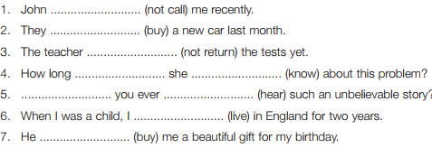

Task 3: Put the words in brackets in the correct place.
- Mr Collins has left another message on my answerphone. (just)
- We invited everybody to our wedding. (last year)
- I have wanted to become a writer. (always)
- Were you in London? (during the holiday)
- Has the performance started? (yet)
- My sister has received a confirmation. (already)

Extra practice:
http://www.perfect-english-grammar.com/support-files/present_perfect_or_past_simple_2.pdf
https://www.english-area.com/paginas/psimplevspperfectoE1.pdf

